**NKIRGIR RAINWATER HARVESTING PROJECT: IMPACT REPORT**

**April 2024**

DISCLAIMER: This study is made possible by the support of The Aqua Nirvana Foundation. The contents of this study are the sole responsibility of The Maa Trust and The Aqua Nirvana Foundation and do not necessarily reflect the views of The Aqua Nirvana Foundation.

# ACKNOWLEDGEMENTS

# This report was prepared by Doreen Ndiema, Getruth Chelangat, Dennis Moriaso. We thank the following reviewers: xxxxxxxxxx at The Aqua Nirvana Foundation. Getruth Chelangat coordinated field teams and helped with data collection. The Maa Trust Nkirgir Rainwater Harvesting Project program in Kenya with support from The Aqua Nirvana Foundation and Chase Africa generously supports Water and Health department-funded activities.

# 

# ABOUT THE AQUA NIRVANA FOUNDATION

# The Aqua Nirvana Foundation, established in 2013, is dedicated to providing access to safe, clean water in the Maasai Mara by implementing sustainable WASH technologies. As a family foundation, it focuses on deploying appropriate water solutions that cater to the specific needs of the community and region. Since 2021, they have partnered with The Maa Trust to further its mission. Their projects primarily involve installing rainwater harvesting systems, such as those at Ng’ila and Nkirgir in the Maasai Mara, alongside spring protection and boreholes with Reverse Osmosis (RO) filters. Overall, they are committed to long-term sustainability and strive to ensure that our initiatives deliver lasting benefits and enhance the well-being of the communities we serve.

# **Executive Summary**

In April 2024, a comprehensive WASH (Water, Sanitation, and Hygiene) survey was conducted in Nkirgir Village, involving 99 households. The survey revealed significant improvements since 2021, notably in water access and quality, sanitation, and hygiene practices. The community rainwater harvesting system has become the primary source of drinking and cooking water for the last 2 years since 2022 when the rainwater harvesting project was launched, drastically reducing reliance on unprotected sources and decreasing the time spent collecting water. Water treatment practices have also improved, with more households using boiling, filtration, and chlorination methods, leading to better water quality and reduced waterborne diseases.

Sanitation facilities have seen substantial upgrades, with a significant increase in functional toilets and hand-washing stations. Participation in WASH training programs has also risen, enhancing community awareness and hygiene practices. Despite these advances, challenges remain, such as the need for expanded water infrastructure, regular maintenance, and ensuring the affordability of water treatment supplies. Continued community involvement and education are crucial to sustaining these improvements. By addressing these areas, Nkirgir Village can build on its progress and ensure a healthier, more sustainable future for all its residents.

**CONTENTS**

Executive Summary 2

**INTRODUCTION** 3

**PROFILE OF RESPONDENTS** 3

Demographic Profile 3

Economic Status of Respondents 3

**WATER (source, collection, storage, and safety) ANALYSIS** 5

1. Water Source and Collection 5

Water Quality 6

Water Safety 6

Water Treatment 7

Other Water Usage 8

2. Waterborne illnesses 9

**SANITATION AND HYGIENE ANALYSIS** 9

WASH Training and Education 9

Toilet Facilities 10

**GENERAL FEEDBACK ON THE RAINWATER HARVESTING PROJECT** 10

Effectiveness and Satisfaction 10

Payment and Affordability 11

Responsibility and Maintenance 11

Summary of Changes Since 2021 and Future Recommendations 11

Changes Since 2021 11

Achievements of 2021 Recommendations 12

Recommendations for Further Improvement 12

Conclusion 13

**List of Figures**

Figure 1: Age range of the participants 3

Figure 2: Water treatment methods 7

Figure 3: waterborne diseases reported 9

**List of Tables**

Table 1: Land ownership in different conservancies 4

Table 2: Sources of water for drinking and cooking 5

Table 3: Cleaning of jerrycans used to collect water 7

Table 4: Water source for washing 8

Table 5: Water source for livestock 8

# **INTRODUCTION**

From April 20th to 24th, 2024, a comprehensive Water, Sanitation, and Hygiene (WASH) survey was conducted in Nkirgir Village. The survey collected data on Household information, Water(Source, collection, storage, and safety), Sanitation & Hygiene, and General feedback on the rainwater harvesting project. A total of 99 participants from various households actively contributed to this study, providing valuable insights into the WASH situation in Nkirgir Village.

# **PROFILE OF RESPONDENTS**

## **Demographic Profile**

The demographic analysis of surveyed households revealed a gender distribution where 70.71% of respondents were female and 29.29% were male. Age-wise, the majority fell between 19-35 years (54.08%), while those over 56 years were only 8.16% as shown in Figure 1 below.

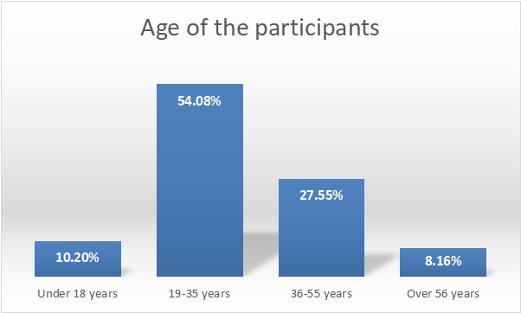

*Figure 1: Age range of the participants*

The average household population of Nkirgir village is 6 people per household which is the same as when the baseline was done in 2021.

## **Economic Status of Respondents**

A significant proportion (64.65%) of households reported land ownership in conservancies, the majority owning it at Mara North conservancy (30.2%), followed by Pardamat conservancy (28.6%) as shown in table 1 below.

Table 1: Land ownership in different conservancies

|  |  |  |
| --- | --- | --- |
| Conservancies | Responses | Percent of Cases |
| N |
| Mara North Conservancy | 19 | 30.20% |
| Pardamat Conservancy | 18 | 28.60% |
| Olare- Motorogi Conservancy(OMC) | 15 | 23.80% |
| Naboisho Conservancy | 13 | 20.60% |

The average monthly income of the respondents was Kshs 23,252, compared to Kshs 20,259 in 2021, which is a 14.8% increase. The household monthly expenditure was Kshs 12, 940 compared to Kshs 13,924 in 2021 which could be an indication of better spending habits for the households.

Housing infrastructure primarily consisted of iron sheet roofs, wood, walls, and earthed floors (60.2%) followed by mud and earthed at 17.4%, while iron sheet, wood, and cement were the least common at only 5.1% as shown in the figure below. While the percentages are different the popularity remains the same as the baseline survey in 2021 where iron sheet, wood, and earthed was at 73.7%, followed by mud and earthed at 20.2% and the least common was iron sheet, wood, and cemented at 1.1%.

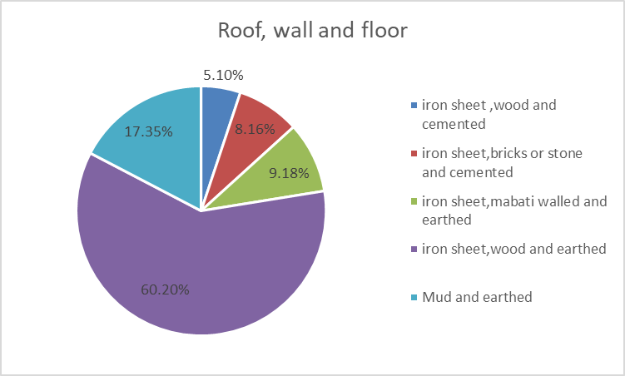

# 

# 

# **WATER (source, collection, storage and safety) ANALYSIS**

## **1. Water Source and Collection**

***Primary water sources*:**

During the impact assessment survey, community rainwater harvesting emerged as the primary source of drinking and cooking water (64.60%), followed by household rainwater harvesting (19.2%) and unprotected springs, wells, dams, or rivers at 11.1% as shown in table 2 below. There is a great shift from 2021 where the unprotected spring/well/ dam/ river was the primary source at 57.4% while only 4% used community rainwater harvesting. This shows that the rainwater harvesting tank built at Nkirgir has been of great help to the community.

|  |  |  |
| --- | --- | --- |
|  | Responses | Percent of Cases |
| N |
| Community Rainwater Harvesting | 64 | 64.60% |
| Household Rainwater Harvesting | 19 | 19.20% |
| Unprotected Spring/well/dam/river | 11 | 11.10% |
| Protected Spring/well with tap | 4 | 4.00% |
| Water vendor | 3 | 3.00% |
| Borehole | 2 | 2.00% |
| Household dam | 1 | 1.00% |

*Table 1:Sources of water for drinking and cooking*

The survey also shows that the walking distance to water sources has changed in the past two years. While in 2021 the average time taken to walk to the water collection point was 3 hours 4 minutes, in 2024 the time has reduced to 2 hours 29 minutes. The reasons given for the reduction include:

1. *Community water projects*: The availability of community water projects has played a significant role in reducing the distance walking to water points, as mentioned by multiple respondents.
2. *Impact of rainfall*: Some respondents noted that the distance walked for water collection changes when it rains
3. *Improved accessibility*: Several respondents mentioned that the water source is now nearer compared to before, making it easier and more convenient to collect water.

Before the rainwater harvesting project at Nkirgir, 45% of the respondents reported experiencing times when there was no drinking/ cooking water available at the source. The reasons they gave for the water not being available include:

* *Seasonal Dependence:* The community relies on rainy seasons for water, so during dry periods, water is very scarce. Boreholes often dry up or get dirty during these times.
* *High Competition:* There is strong competition between people and livestock for the limited water.A growing population makes the situation worse, leading to overcrowding at water sources.
* *Infrastructure Problems:* Water systems frequently break down or have faults, such as damaged pipes, which are often not repaired quickly.Sometimes, the watchman who collects water fees is not present, so people can't get water without paying.
* *Water Quality Issues:* Water sources can become contaminated with dirt or animal waste, making the water unsafe to drink.
* *Wildlife Interference:* Animals, like elephants, sometimes destroy water sources, adding to the water shortage problems.

## Water Quality

The quality of water from different sources varies significantly in the community. Community rainwater harvesting is generally well-regarded, with most feedback being positive, indicating it as a reliable and clean source of water. Similarly, protected springs or wells with taps are perceived as high-quality water sources, receiving overwhelmingly positive feedback. On the other hand, water from unprotected springs, wells, dams, or rivers tends to receive mixed feedback, with concerns about contamination and overall quality. Water vendors also receive variable feedback, indicating an inconsistency in the water quality they provide.

|  |  |  |  |  |
| --- | --- | --- | --- | --- |
| Water Source | Negative | Neutral | Positive | Uncategorized |
| Borehole | 0 | 0 | 1 | 0 |
| Community Rainwater Harvesting | 13 | 5 | 38 | 3 |
| Household Rainwater Harvesting | 4 | 2 | 6 | 6 |
| Household dam | 0 | 0 | 1 | 0 |
| Protected Spring/well with tap | 0 | 0 | 2 | 1 |
| Unprotected Spring/well/dam/river | 2 | 5 | 2 | 2 |
| Water vendor | 1 | 0 | 1 | 1 |

*Table 2: Quality of drinking water from different sources*

## Water Safety

Mothers were predominantly responsible for water collection (92.86%), ensuring that 88.89% of households reported water protection from contamination. Most households (85.71%) practiced some form of water treatment, including boiling and chlorination being the most used methods. 99% of the households reported having the jerrycans used to collect water cleaned frequently with the majority (53.1%) using water and animal poo or leaves or sand as shown in Table 3 below. There has been a drop in those using water and poo from 73% in 2021 to 53.1% in 2024, while those using water and soap have increased from 26% to 38.5%. The increasing use of soap as opposed to poop/leaves/ sand is attributed to the WASH training given by the Maa Trust that encourages them to use soap for cleaning.

|  |  |  |
| --- | --- | --- |
|  | Responses | Percent of Cases |
| N |
| Water only | 6 | 6.3% |
| Water and animal poo/leaves/ sand | 51 | 53.1% |
| Water and soap | 37 | 38.5% |
| Adding chlorine | 2 | 2.1% |

## *Table 3: Cleaning of jerrycans used to collect water*

## 

## Water Treatment

38.4% of the participants reported boiling water as a method of water treatment, an increase from 32% in 2021. Those who use filtration have also increased from 6% to 20.2%, and chlorination from 1% to 24.2%. This is a good indication that the community at Nkirgir is more purposeful with water safety, with a lot more people using some form of water treatment.

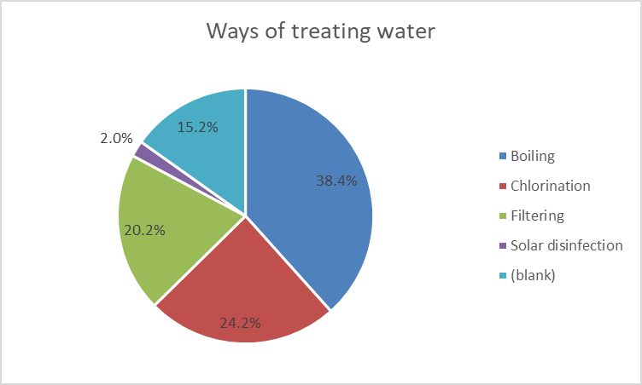

*Figure 2: Water treatment methods*

The respondents stated that these changes are driven by various factors, including the availability of rainwater, increased access to chlorine in local shops, and the implementation of community water projects complemented by training that promotes improved treatment methods like filtering and boiling. Additionally, the reduced distance to water sources has facilitated easier access to clean water.

The specific changes in treatment methods include the addition of chlorine, which many respondents use for its effectiveness in killing germs and improving water quality. Filtering has also become more common, providing a reliable means to ensure cleaner water. Boiling water is another popular method, particularly in areas where other treatments are less accessible.

These new treatment methods have positively impacted water quality, with respondents noting improvements in taste and smell. The treated water is now safer for health, with fewer germs present, and clean water is more readily available, contributing to better overall health in the community.

However, challenges persist. Economic constraints prevent some people from affording chlorine or other treatment supplies, leading to inconsistent use. The variability in treatment methods results in differences in water quality. Despite these challenges, the shift towards better water treatment practices marks significant progress for the community.

## Other Water Usage

*Table 4 : Water source for washing*

|  |  |
| --- | --- |
| Source | Percent |
|
| Household Rainwater Harvesting | 17.3% |
| Community Rainwater Harvesting | 17.3% |
| Unprotected community spring/well/dam/river | 66.3% |
| Protected Spring/well with tap | 4.1% |
| Borehole | 4.1% |

*Table 5: Water source for livestock*

|  |  |
| --- | --- |
| Source | Percent |
|
| Community Rainwater Harvesting | 5.1% |
| Unprotected Spring/well/dam/river | 83.8% |
| Protected Spring/well with trough | 11.1% |
| Borehole | 1.0% |

The community is encouraged to reserve the use of community rainwater harvesting exclusively for drinking and cooking to ensure the availability of clean and safe water for these essential purposes. However, the data reveals that community rainwater harvesting is currently being utilized for other purposes as well. Specifically, 17.3% of the water used for washing comes from community rainwater harvesting, and 5.1% of the water used for livestock also originates from this source. On the upside, the majority of water for washing (66.3%) and for livestock (83.8%) is drawn from unprotected springs, wells, dams, or rivers. To maintain the quality and availability of water for drinking and cooking, it is crucial for the community to rely more on alternative sources like unprotected springs or boreholes for non-consumptive uses. This shift would help preserve the higher quality water collected from community rainwater harvesting systems for its intended essential uses.

## **Waterborne illnesses**

Despite water treatment efforts, waterborne illnesses were prevalent, with typhoid (54.5%), diarrhea (25.3%), and cholera (23.2%) being the most reported. The frequency of these illnesses varied among households. This is a slight drop from 2021 where typhoid was at 54.9%, diarrhea at 42.4%, and muscle pain at 34.0%. However, cholera has shot up from 1.4% to 23.2% which is quite worrying. There is, therefore, a need to query this trend and find a solution for it.

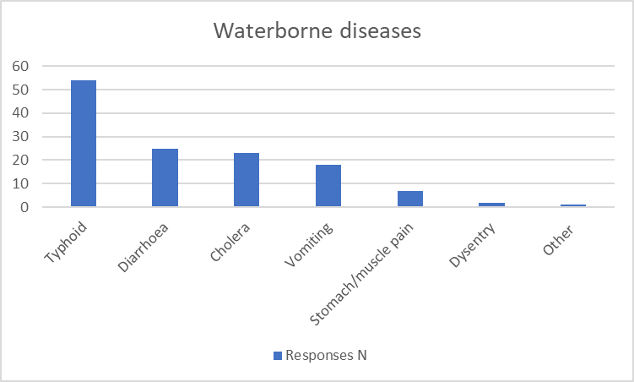

*Figure 3: waterborne diseases reported*

However, when asked if after implementing the rainwater harvesting tanks, the number of waterborne diseases has dropped, 73% responded in the affirmative suggesting that improved access to clean water has led to a reduction in waterborne diseases.

# **SANITATION AND HYGIENE ANALYSIS**

## **WASH Training and Education**

A significant portion of respondents (32.32%) have participated in WASH training within the past two years, primarily conducted by The Maa Trust, and Amref. This is an increase from 18.1% reported in 2021. Feedback on the training sessions was generally positive, with respondents finding them to be good or very good, highlighting the effectiveness of these educational initiatives.

## **Toilet Facilities**

The majority of households (60.61%) have fully functional toilets, predominantly pit latrines with slabs or ventilated pit latrines, a significant increase from 2021 when only 11.2% had access to toilets.

Most users (63.64%) feel safe using the toilet facilities both during the day and at night. The majority of households (61.62%) have access to water, soap, and cleaning materials for toilet flushing, hand-washing, and cleaning of toilet facilities, promoting hygiene practices.

Challenges regarding maintenance are evident, with 45.92% of respondents never having emptied or rebuilt their toilets. Waste disposal practices vary, with dumping sites in the homestead (35.71%) and in the bush (36.73%) being the most common locations for waste disposal.

Despite challenges, the presence of hand-washing stations near toilets in the majority of households 61.62% compared to 6.5% in 2021, with 85.00% having water and soap available, indicates a positive step towards promoting hygiene.

# **GENERAL FEEDBACK ON THE RAINWATER HARVESTING PROJECT**

## **Effectiveness and Satisfaction**

The majority of respondents (90.91%) agree that the Community Rainwater Harvesting (CRWH) project has helped provide clean and safe water. A small percentage (8.08%) partially agree, indicating some room for improvement in the following ways as suggested:

1. *Adding more infrastructure*: This involves expanding the network of pipes, tanks, taps, and other water distribution systems to reach more areas within the community, ensuring that everyone has access to clean water.
2. *Enhancing technology and resources*: Incorporating solar energy into the water project can make it more sustainable and cost-effective in the long run.
3. *Improving maintenance and treatment:* Regular maintenance is crucial for preventing breakdowns and ensuring the longevity of the water project.
4. *Increasing accessibility and affordability*: Bringing water sources closer to homesteads can reduce the distance that community members need to travel to access clean water, making it more convenient for everyone.
5. *Educating and promoting responsibility:* Educating community members about water preservation and hygiene practices can help ensure that water resources are used wisely and sustainably.
6. *Water treatment:* Many respondents emphasized the importance of chlorination to ensure water safety and reduce contamination and implement filtration systems to improve water quality.

Over the last year, many reported breakdowns in the water project, suggesting a need for enhanced maintenance. Encouragingly, the majority (97.14%) reported issues to the project management committee, highlighting proactive community involvement. Nearly all respondents (94.95%) are aware of the project committee, demonstrating strong community engagement. Interestingly, all respondents (100%) believe the project committee is doing a good job, indicating satisfaction with their efforts.

## Payment and Affordability:

Payment for water varies, with the majority paying Ksh2 per 20-liter jerrycan. Payment frequency is primarily monthly. A significant majority (81.82%) are willing to pay for water from the rainwater harvesting project, showing community support.

## Responsibility and Maintenance:

Regarding responsibility for maintenance, opinions are split: The majority believe the project committee should be responsible, while others think it should be the community water users. Some also suggested donors take responsibility for maintenance.

## **Summary of Changes Since 2021 and Future Recommendations**

## **Changes Since 2021**

Since the baseline survey conducted in 2021, several significant improvements have been observed in Nkirgir Village's water, sanitation, and hygiene (WASH) situation:

1. Water Source and Collection:
   * Primary Water Source: The community rainwater harvesting system has become the primary source for drinking and cooking water, with usage increasing from 4% in 2021 to 64.6% in 2024. This shift indicates the success of the communal rainwater harvesting system in providing clean water.
   * Walking Distance: The average time taken to collect water has decreased from 3 hours 4 minutes to 2 hours 29 minutes, attributed to new community water projects and improved accessibility.
2. Water Quality and Treatment:
   * Treatment Methods: The use of water treatment methods has increased, with boiling rising from 32% to 38.4%, filtration from 6% to 20.2%, and chlorination from 1% to 24.2%. This reflects a growing awareness and adoption of water safety practices.
   * Water Quality Feedback: Positive feedback on water quality from community rainwater harvesting and protected springs has increased, indicating better water safety and taste.
3. Sanitation and Hygiene:
   * Toilet Facilities: The proportion of households with fully functional toilets has risen from 11.2% in 2021 to 60.61% in 2024. The presence of hand-washing stations near toilets has also increased from 6.5% to 61.62%, with 85% having water and soap available.
   * WASH Training: Participation in WASH training has increased from 18.1% in 2021 to 32.32%, with positive feedback on the effectiveness of these sessions.
4. Health Improvements:
   * Reduction in Waterborne Illnesses: There has been a notable decrease in cases of waterborne diseases such as typhoid, diarrhea, and cholera. Improved water treatment and better access to clean water have contributed to this decline.

## **Achievements of 2021 Recommendations**

The recommendations from 2021 focused on constructing a communal rainwater harvesting system, reducing water collection time, and improving sanitation through health education. The following achievements indicate progress:

1. Communal Rainwater Harvesting System: The successful construction and utilization of the communal rainwater harvesting system have significantly improved access to clean water, reducing the reliance on unprotected sources.
2. Reduced Water Collection Time: New water projects have shortened the distance to water sources, allowing residents to invest time in other activities and reducing the risk of wildlife attacks.
3. Improved Sanitation: Basic health education and community capacity building have led to better sanitation practices, increased toilet facilities, and reduced open defecation.

## **Recommendations for Further Improvement**

1. Enhanced Water Treatment and Quality:
   * Expand Chlorination and Filtration: Increase the availability and consistent use of chlorine and filtration systems to maintain high water quality.
   * Regular Monitoring: Implement regular water quality monitoring to ensure safety and address any contamination promptly.
2. Infrastructure Expansion and Maintenance:
   * Build More Storage Tanks and Pipelines: Extend the infrastructure to cover more areas, ensuring all households have close access to clean water.
   * Implement Regular Maintenance Programs: Ensure regular maintenance to prevent failures and protect the infrastructure.
3. Promote Hygiene and Sanitation:
   * Increase WASH Training: Continue and expand WASH training programs to further improve hygiene practices.
   * Enhance Toilet Facilities: Increase the number of functional toilets and ensure they are well-maintained and hygienic.
4. Community Involvement and Education:
   * Foster Community Responsibility: Encourage community members to take an active role in maintaining water and sanitation facilities.
   * Educate on Water Preservation: Provide ongoing education on water preservation and hygiene to ensure sustainable use of resources.
5. Address Economic Constraints:
   * Affordable Water Supplies: Ensure water treatment supplies like chlorine are affordable and accessible to all households.

# **CONCLUSION**

Since the 2021 baseline survey, Nkirgir Village has made remarkable strides in improving its water, sanitation, and hygiene (WASH) conditions. The successful implementation of the communal rainwater harvesting system has significantly increased access to clean water, reducing reliance on unprotected sources and the time spent collecting water. Enhanced water treatment practices, increased participation in WASH training, and improved sanitation facilities have collectively contributed to a notable reduction in waterborne illnesses. However, there is still room for improvement. Expanding water infrastructure, ensuring regular maintenance, promoting consistent use of effective water treatment methods, and fostering community involvement and education are crucial steps forward. By continuing to build on these achievements and addressing the remaining challenges, Nkirgir Village can ensure a healthier, safer, and more sustainable future for all its residents.